**ASSIGNMENT - 8**

1. In Python, what is the difference between a built-in function and a user-defined function? Provide an example of each.

Ans: If you define the function yourself, it is a user-defined function. On the other hand, the Python function that comes along with Python is known as an in-built function. All the functions apart from in-built functions and library functions come under the category of user-defined functions.

User-defined function-

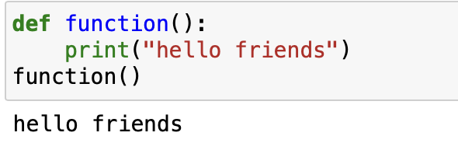

Built-in functions- max(), input(),int(),min(),etc….

1. How can you pass arguments to a function in Python? Explain the difference between positional arguments and keyword arguments.

Ans: Arguments are specified after the function name, inside the parentheses.

Positional arguments must be included in the correct order. Keyword arguments are included with a keyword and an equal sign.

1. What is the purpose of the return statement in a function? Can a function have multiple return statements? Explain with an example.

Ans: A return statement ends the execution of a function, and returns control to the calling function.

A function can have multiple return values.

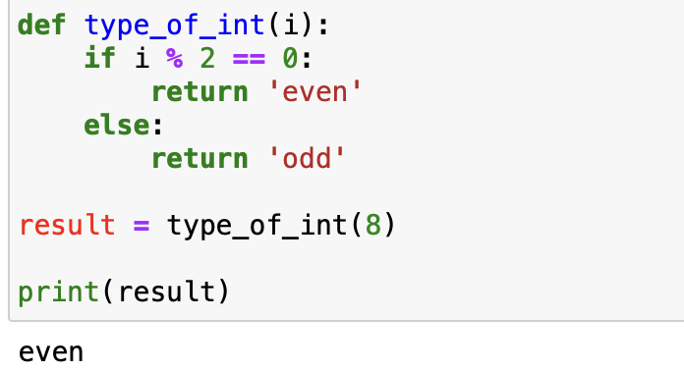

1. What are lambda functions in Python? How are they different from regular functions? Provide an example where a lambda function can be useful.

Ans: Python Lambda Functions are anonymous function means that the function is without a name.

A lambda function is an anonymous function (i.e., defined without a name) that can take any number of arguments but, unlike normal functions, evaluates and returns only one expression. Note that, unlike a normal function, we don't surround the parameters of a lambda function with parentheses.

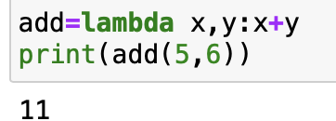

1. How does the concept of "scope" apply to functions in Python? Explain the difference between local scope and global scope.

Ans: Every time you call a function, you create a new local scope—a namespace where names created inside the function usually live.

Variables are classified into Global variables and Local variables based on their scope. The main difference between Global and local variables is that global variables can be accessed globally in the entire program, whereas local variables can be accessed only within the function or block in which they are defined.

1. How can you use the "return" statement in a Python function to return multiple values?

Ans: 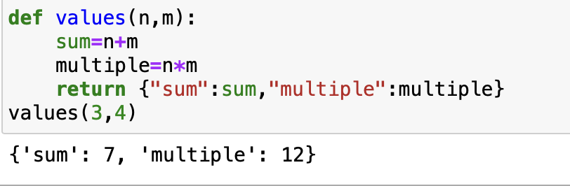

1. What is the difference between the "pass by value" and "pass by reference" concepts when it comes to function arguments in Python?

Ans: Pass by reference means that you have to pass the function(reference) to a variable which refers that the variable already exists in memory. Here, the variable( the bucket) is passed into the function directly. The variable acts as a Package that comes with its contents(the objects).

1. Create a function that can intake integer or decimal value and do following operations:
   1. Logarithmic function (log x)
   2. Exponential function (exp(x))
   3. Power function with base 2 (2x)
   4. Square root

Ans:

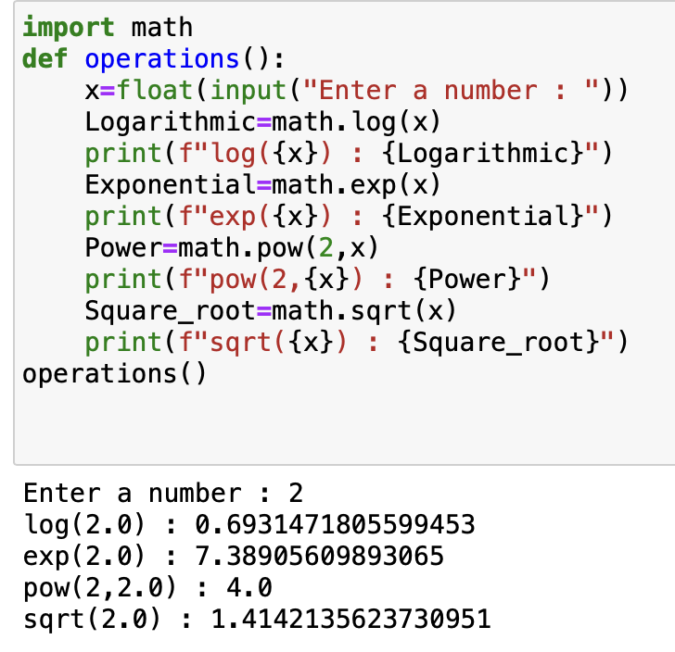

1. Create a function that takes a full name as an argument and returns the first name and last name.

Ans: 